ARTIFICIAL INTELLIGENCE IN TRANSPORTATION INDUSTRY

Vupputuri Bharath

*AIT-CSE, AIML*

*Chandigarh University, Punjab, India*

[bharathupputuri@gmail.com](mailto:bharathupputuri@gmail.com)

Gottipalli Sai Prasanth

*AIT-CSE, AIML*

*Chandigarh University, Punjab, India*

[Saiprasanth495@gmail.com](mailto:Saiprasanth495@gmail.com)

Kethuri Ajay

*AIT-CSE, AIML*

*Chandigarh University, Punjab, India*

[ajaykethuri@gmail.com](mailto:ajaykethuri@gmail.com)

Koyyada Akshay Kumar

*AIT-CSE, AIML*

*Chandigarh University, Punjab, India*

[akshay.k0520@gmail.com](mailto:akshay.k0520@gmail.com)

***Abstract- The aim of this study is to observe the integration of AI(Artificial Intelligence) in the transportation industry. This study explores the multifaceted role of AI in revolutionizing various domains within transportation ranging from traffic management and safety in traffic to logistics and predictive maintenance. Here a model is created for Safety in transportation based on Driver Fatigue Monitoring using OpenCv , Computer vision and deep learning techniques. Using profuse machine learning models such as Logistic Regression, Support Vector Machine, Random Forest, K Nearest Neighbor classified to respective categories and then trained and tested. Analyzing the results and giving the conclusion based on that.***

* 1. NTRODUCTON

Artificial intelligence is revolutionizing the way we travel and ensuring our safety on the roads. As technology continues to advance at a rapid pace, it is becoming increasingly important for the transport industry to keep up with the latest innovations. One such innovation is the use of AI-powered systems, which have the potential to transform the way we move around. From traffic management systems, AI has already made significant strides in improving the efficiency and safety of transportation. But perhaps one of its most important applications is in the area of driver fatigue monitoring.

Driver fatigue is a serious issue that affects millions of people every year. It can lead to accidents, injuries, and even fatalities. By using AI to detect signs of fatigue in drivers, we can prevent these tragedies from occurring and make our roads safer for everyone.

Studies indicate that a driver is typically exhausted after an hour of driving. There is a significant increase in driver fatigue and drowsiness in the late afternoon and early evening, after lunch, and at midnight. Moreover, hypnotic medication use, alcohol consumption, and drug addiction can all result in unconsciousness.

Distinct statistics have been reported in various countries regarding the number of accidents caused by distracted and/or fatigued drivers. Generally speaking, driver fatigue and distraction account for 20% of collisions and 30% of fatal collisions. Up to 50% of accidents involving heavy vehicles or single-vehicle crashes (collisions in which only one vehicle sustains damage) are caused by driver hypervigilance. Based on current research, it is anticipated that driver fatigue monitoring systems will reduce crashes by 10% to 20%..

Based on the analysis of driver face images, the driver fatigue monitoring system is a real-time system that looks into the physical and mental health of the driver. Eye closure, eyelid distance, blinking, gaze direction, yawning, and head rotation can all be used to infer the driver's state. When there are hypervigilance states, such as weariness and distraction, this system will sound an alarm. The intelligent software and imaging are the main components of the driver fatigue monitoring system.

* + 1. LITERATURE SURVEY

Driver fatigue Monitoring Systems is a Major area that focuses on the safety in Transportation Industry.

In [1] 2019, A. Subbarao and K. Satithya outlined the various hardware approaches for drivers

sleepiness, and the eye blink sensor is one of the components they used. A buzzer is used to alert the driver when it detects drowsiness due to an eye blink sensor.

In [2] 2019, The evaluation of this system used three image datasets: the first data set had images with a uniform background, the second data set was based on face deformations, and the third data set included videos of people driving cars. Muhammad Tayab Khan and Hafeez Anwar implemented driver drowsiness detection in real-time surveillance videos based on eyelid closure.

In [3] 2019,Sukrit Mehta, Sharad Dadhich, and Sahil Gumber employed a real-time drowsiness detection system that computes ear based on adaptive thresholding and random forest. The system uses eye aspect ratio and eye closure ratio EAR AND ECR, which are capable of detecting facial landmarks..

In [4] 2018, Gianfranco Fancello and Mariangela Daga conducted research and analysis on professional bus drivers' driving behaviours . The results of the Multiple Correspondences Analysis (MCA) data analysis indicate that there is a relationship between the driver's age and body weight and the perceived level of discomfort in a particular set of body areas.

In [5] 2017, Ramalatha Marimuthu conducted research on driver fatigue detection using image processing. She also worked on accident prevention using image processing and an alert system that lights up and off a specific vehicle to warn drivers.

In [6] 2016, Suhas Katkar created a system in that employs an IR sensor to detect weariness and an alcohol sensor to detect intoxication. The system then sounds an alarm, kills the engine, and sends the owner a message along with its location.

In [7] 2015, Raees Ahmad created a system in that records a driver's head movements with a web camera in order to identify sleepiness and signal to the driver.

In [8] 2012, In order to notify the owners through vibrations in the steering wheel, Susanna Leanderson Olsson mimicked blink behavior-based indicators and a lane position monitoring system in .

In [9] 2012, active infrared lights are used for illumination and remotely placed charge-coupled device cameras are used to capture video images of the driver's face. The degree of fatigue is assessed using a variety of visual cues, including the movements of the head, eyelid, and gaze in addition to the expression on the face.

In [10] 2010, Xiao Fen employed dynamic facial image sequences in conjunction with a Gabor-based representation to identify and track human fatigue. The Adaboost algorithm, feature fusion, and feature extraction are used to determine which feature to identify fatigue.

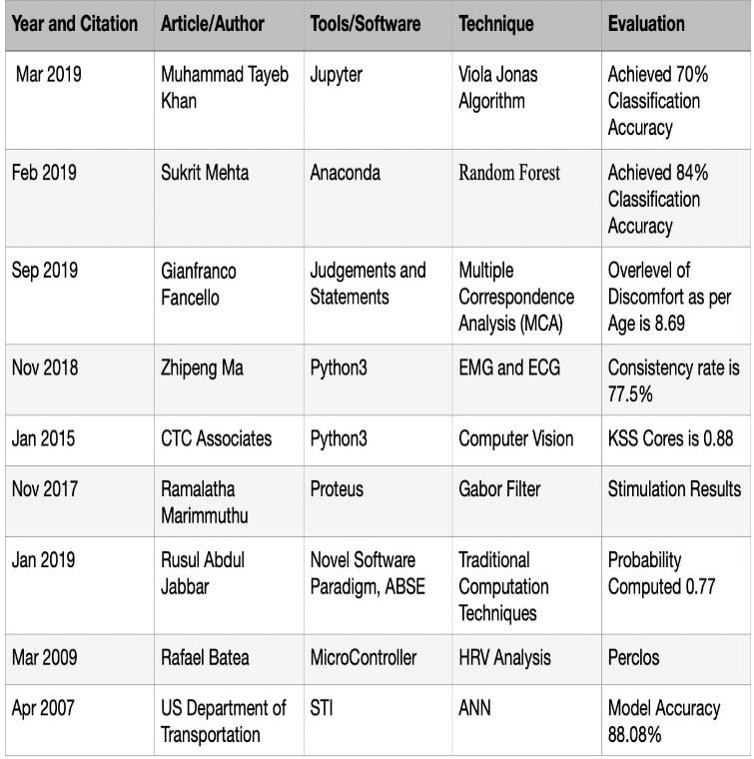

*FIGURE 1: RESEARCH ARTICLES*

* + 1. PROPOSED SYSTEM

Here in this study, we are trying to show how driver fatigue system is working using different Machine Learning Models for classifying the extracted data. Hence, this drives us to create and analyze the models on this data. Eye aspect ratio from driver’s face are taken out by manually by using pre-defined EAR dataset. Collected dataset is applied using many ML models techniques like Random Forest, Logistic regression, Bernoulli Naive Bayes, Support vector machine, KNN etc. Lastly, observing results we can conclude how the models are working for the study and which is the best model for Driver fatigue system. This helps us to know the trends on some models and how people are responding for it.

* + 1. PROBLEM STATEMENT

In this project, we try to implement different types of classifiers that helps to overcome the challenges of driver fatigue. Design and implement a Driver Fatigue Monitoring System that utilizes technology to detect and alert drive. Driver fatigue poses a significant challenge in the realm of AI-driven transportation systems, necessitating a comprehensive understanding of the relationship between eye blink patterns and fatigue levels. Despite the availability of datasets capturing various instances of driver fatigue, the

correlation between the distance between the two eyelids and the onset of fatigue remains inadequately explored. Therefore, the development of a robust AI model that can accurately analyze and interpret the data pertaining to the distance between the two eyelids in conjunction with established fatigue patterns is imperative. Such a model would significantly contribute to the enhancement of early detection systems for driver fatigue, leading to improved road safety and the prevention of potential accidents.

* + 1. METHODOLOGY

In this study there are primarily 2 stages to it. Every stage is so vital and helps in building the efficient model. Following below are the steps:

1. Model Selection
2. Model Evaluation.
3. Model Selection

Here different machine learning models are used. they are as follows:

1. Logistic Regression
2. Support Vector Machine
3. Bernoulli Naïve Bayes
4. Random Forest
5. K Nearest Neighbor
6. Linear Discriminant Analysis
7. In this project, the first model used for the outcome of the project is the Logistic regression. Logistic regression is used to classify the labels from the given data. Logistic regression is basically Boolean type model where it says the input belongs to label 1 or label 2. The extracted features are loaded into this model and it is being processed and output is given. First using train_test_split function our data is split into two parts which are used for training the data and testing the data. It is split into 80:20 percent because it is the ideal split for logistic regression. Using the features logistic regression is trained by 80 percent of the data and it stores the features like specific eyes and mouth ratios f. Further in testing it uses those features which are the main ratios for that recognition.
8. Next used is SVM classifier which uses the kernel trick. Kernel trick finds the optimal line of the entire data. It classifies the data by creating a hyperplane and labels are opposite side of the hyperplane. If a data point is given for testing it decides which side it should lie.
9. Bernoulli Naive Bayes is one of the variants of the

Naive Bayes algorithm in machine learning. It is very useful to be used when the dataset is in a binary distribution where the output label is either present or absent.

1. Random Forest is a powerful classifier because it uses decision trees and ensemble learning. It uses numerous classifiers to classify the data. It splits the data randomly and averages the inside models.
2. K Nearest Neighbor classifier also used to analyze how it is behaving for the given data since it is also widely used classifier. It uses proximity for classification.
3. Linear Discriminant Analysis is a recent classifier. It generally used for dimensionality reduction and as a classifier. It is used for versatility of the project.
4. Model Evaluation

Model evaluation is the final stage of the project. This shows the results by calculating some of the main parameters for a model. It calculates the accuracy, confusion matrix, precision score, recall, F1 score and so on. The key parameters are accuracy and confusion matrix. Both majorly signifies how the model is working first confusion matrix is calculated using formulas. Using the information from confusion matrix accuracy is measured. Accuracy says how well the model is classifying the input tweets or the text.

* + 1. RESULTS/OUTPUTS

# Logistic Regression:

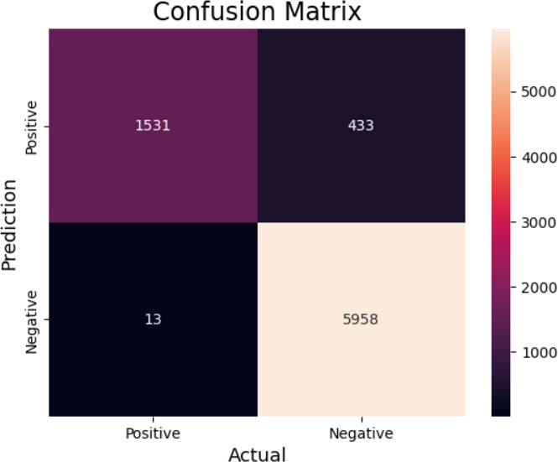

*FIGURE 2: CONFUSION MATRIX FOR LOGISTIC REGRESSION*

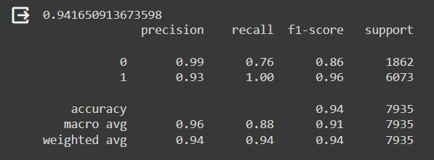 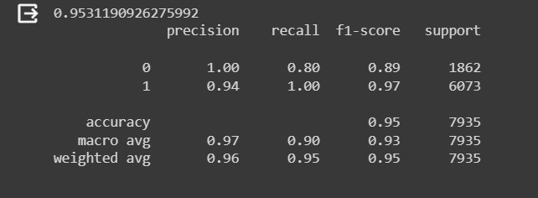

*FIGURE 3: CLASSIFICATION SCORE FOR LOGISTIC REGRESSION*

Fig. [3] The project and study created by us showed a significant accuracy of 94.1 percentage for Logistic Regression

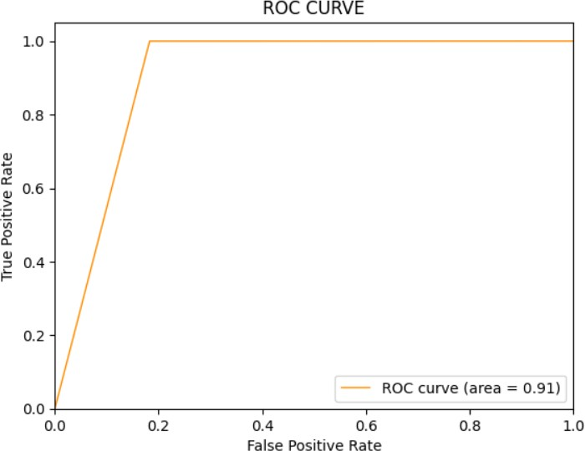

*FIGURE 4: ROC CURVE FOR LOGISTIC REGRESSION*

# Random forest:

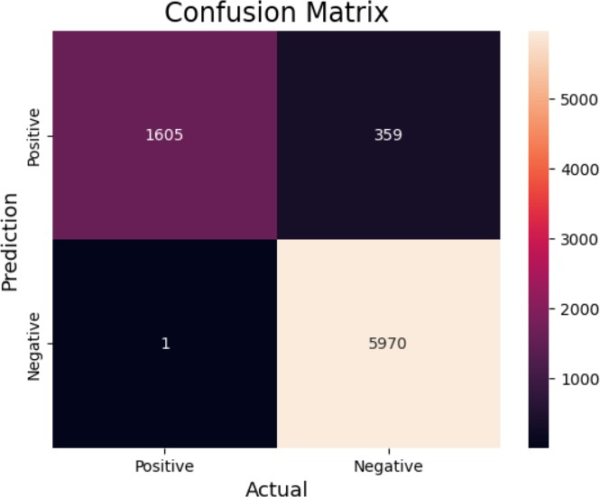

*FIGURE 5: CONFUSION MATRIX FOR RANDOM FOREST*

*FIGURE 6: CLASSIFICATION SCORE FOR RANDOM FOREST*

Fig. [6] The project and study created by us showed a significant accuracy of 95.3 percentage for Random Forest

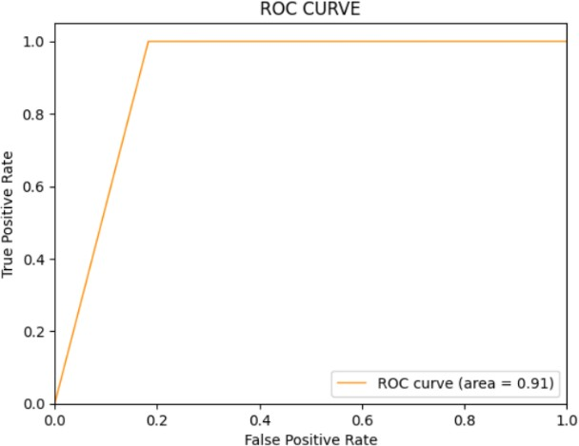

*FIGURE 7: ROC CURVE FOR RANDOM FOREST*

* 1. **Support Vector Machine:**

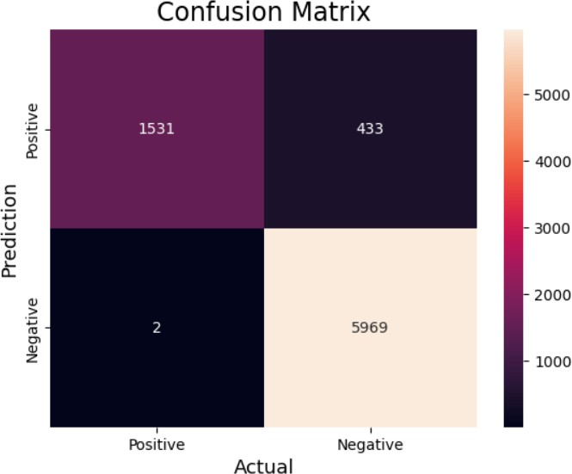

*FIGURE 8: CONFUSION MATRIX FOR SUPPORT VECTOR MACHINE*

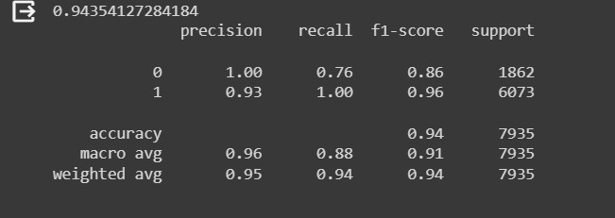

*FIGURE 9: CLASSIFICATION SCORE FOR SUPPORT VECTOR MACHINE*

Fig. [9] The project and study created by us showed a significant accuracy of 94.3 percentage for SVM

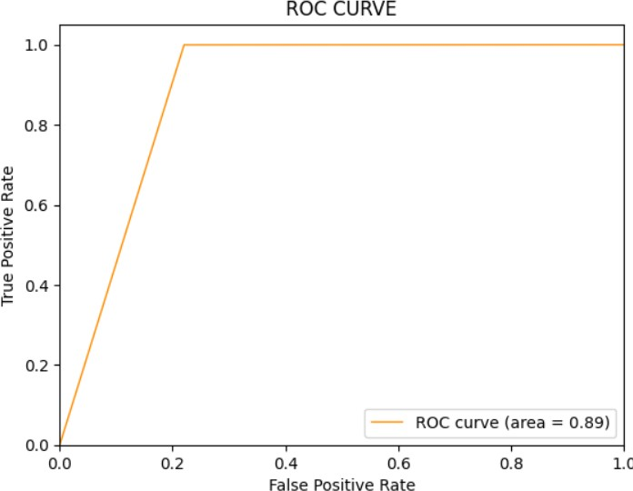

*FIGURE 10: ROC CURVE FOR SUPPORT VECTOR MACHINE*

# Bernoulli Naïve Bayes:

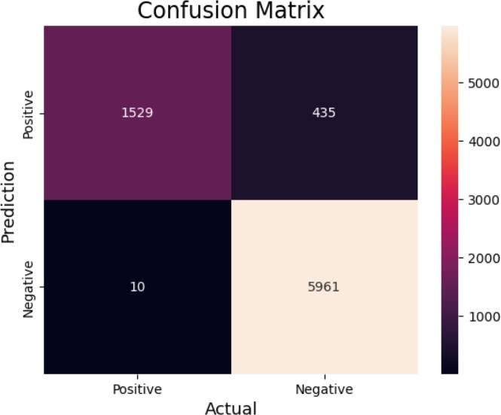

*FIGURE 11: CONFUSION MATRIX FOR BERNOULLI NAÏVE BAYES*

*FIGURE 12: CLASSIFICATION SCORE FOR BERNOULLI NAÏVE BAYES*

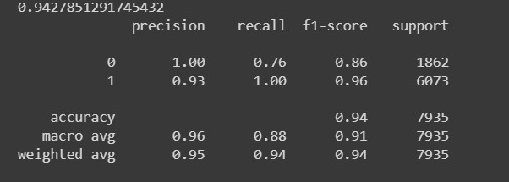Fig. [12] The project and study created by us showed a significant accuracy of 94.2 percentage for Bernoulli Naïve Bayes

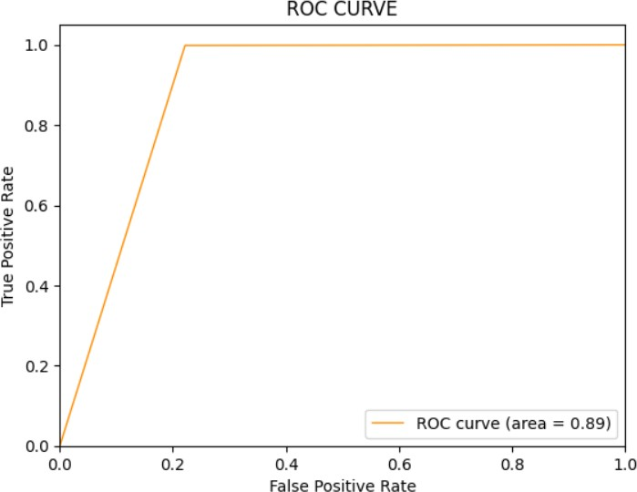

*FIGURE 13: ROC CURVE FOR BERNOULLI NAÏVE BAYES*

# K Nearest Neighbor:

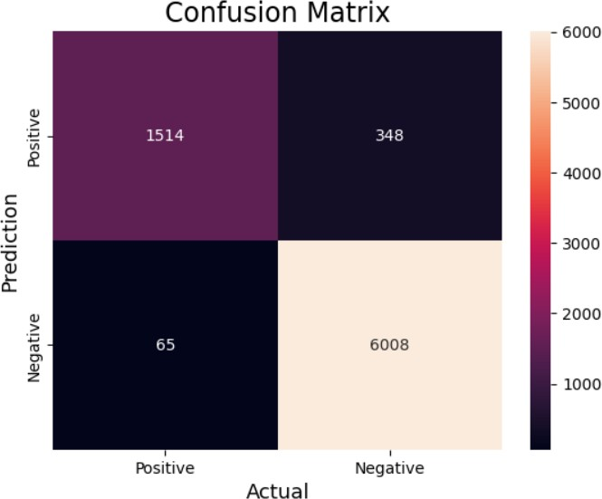

*FIGURE 14: CONFUSION MATRIX FOR KNN*

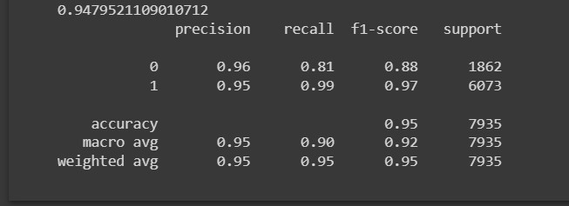 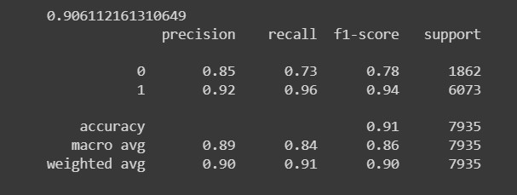

*FIGURE 15: CLASSIFICATION SCORE FOR KNN*

Fig. [15] The project and study created by us showed a significant accuracy of 94.7 percentage for KNN

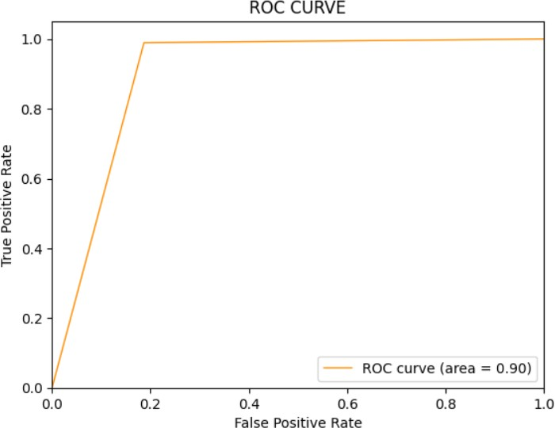

*FIGURE 16: ROC CURVE FOR KNN*

# Linear Discriminant Analysis:

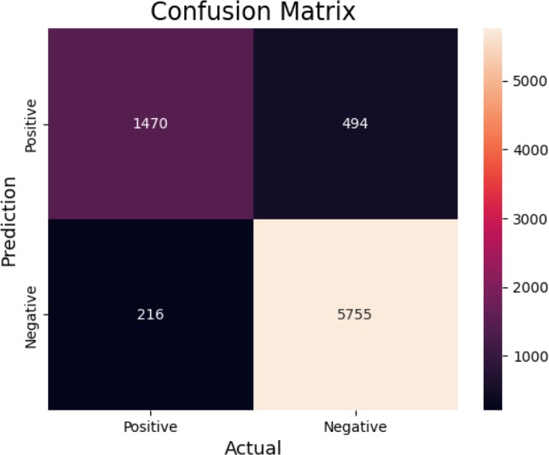

*FIGURE 17: CONFUSION MATRIX FOR LDA*

*FIGURE 18: CLASSIFICATION SCORE FOR LDA*

Fig. [18] The project and study created by us showed a significant accuracy of 90.6 percentage for LDA

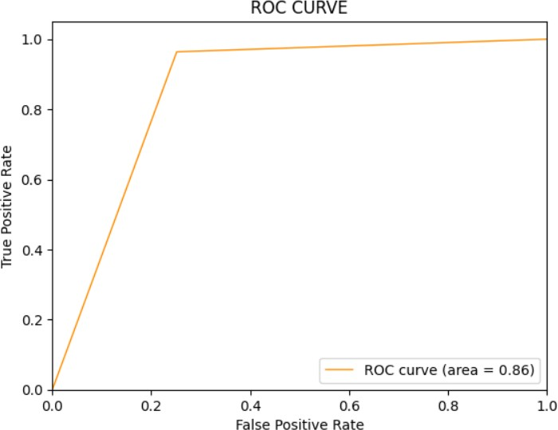

*FIGURE 19: ROC CURVE FOR LDA*

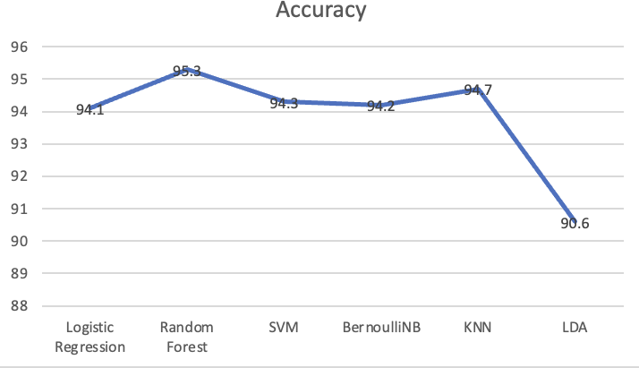

*FIGURE 20: ACCURACY OF CLASSIFIERS*

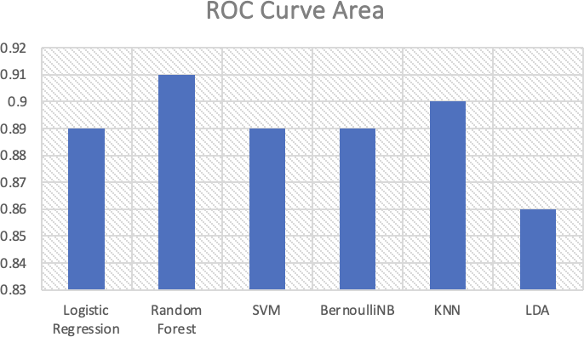

*FIGURE 21: ROC CURVE OF CLASSIFIERS*

1. CONCLUSION AND FUTURE SCOPE

The project presents the findings and outcomes of the study based on the data collected and analyzed. This section aims to provide a comprehensive understanding of the performance of the machine learning model employed for Driver Fatigue Monitoring System and the insights derived from the analysis where the data is retrieved from Kaggle. The datasets consists of Mouth Aspect ratio, Eye Aspect ratio, the distance between the points created on the eyes and mouth. The model's performance was assessed using multiple measures such as accuracy, precision, recall, and F1-score. The analysis results show that the machine learning model did well in driver fatigue monitoring.

Driver fatigue monitoring systems (DFMS) can greatly increase road safety by identifying and warning drivers who are starting to feel sleepy. These systems can determine a driver's state of awareness by observing several cues, including eye movements, facial expressions, and signaling from the body.

1. REFERENCES
2. Subbarao, A., Sahithya, K. (2019) Driver Drowsiness Detection System for Vehicle Safety, International Journal of Innovative Technology and Exploring Engineering (IJITEE).
3. Z. E. Bowden and C. T. Ragsdale, “The truck driver scheduling problem with fatigue monitoring,” Decision Support Syst., vol. 110, pp. 20–31, Jun. 2018.
4. A. Mittal, K. Kumar, S. Dhamija, and M. Kaur, “Head movement based driver drowsiness detection: A review of state-of-art techniques,” in Proc. IEEE Int. Conf. Eng.

Technol. (ICETECH), Mar. 2016

[4]. Consensus Statement: Fatigue and accidents in transport operations. J. Sleep Res. 9, 395 (2000)

1. Horne, J., Reyner, L.: Vehicle accidents related to sleep: a review. Occupational and Environmental Medicine 56, 289–294 (1999) 10
2. Zhang, G.; Yau, K.K.; Zhang, X.; Li, Y. Traffic accidents involving fatigue driving and their extent of casualties. Accid. Anal. Prev. 2016.
3. Chaudhuri, A.; Routray, A. Driver Fatigue Detection through Chaotic Entropy Analysis of Cortical Sources Obtained From Scalp EEG Signals. IEEE Trans. Intell. Transp. Syst. 2019.
4. R. Bittner, K. Hána, L. Poušek, P. Smrka, P. Schreib and P. Vysoký, Detecting of Fatigue States of a Car Driver, ISMDA 2000, LNCS 1933, pp. 260–274, 2000
5. Yu, J., Park, S., Lee, S., & Jeon, M. (2018). Driver drowsiness detection using condition-adaptive representation learning framework. IEEE transactions on intelligent transportation systems, 20(11), 4206- 4218.
6. W. Zhang, B. Cheng and Y. Lin, “Driver drowsiness recognition based on computer vision technology”, Tsinghua Science and Technology, Vol. 17, No. 3, pp. 354-362, 2012.
7. M. Singh, G. Kaur, “Drowsiness detection on eye blink Duration using algorithm”, International Journal of Emerging Technology and Advanced Engineering, Vol. 2, Issue 4, April 2012.
8. Sukrit Mehta, Sharad Dadhich, Sahil Gumber, Arpita Jadhav Bhatt (2019). Real-Time Driver Drowsiness Detection System Using Eye Aspect Ratio and Eye Closure Ratio International Conference on Sustainable Computing in Science, Technology and Management.
9. Tayab Khan, M., Anwar, H., Ullah, F., Ur Rehman, A., Ullah, R., Iqbal, A., … Kwak, K. S. (2019). Smart Real- Time Video Surveillance Platform for Drowsiness Detection Based on Eyelid Closure. Wireless Communications and Mobile Computing, 2019.
10. RamalathaMarimuthu, A. Suresh, M. Alamelu and S.Kanagaraj “Driver fatigue detection using image processing and accident prevention”, International journal of pure and applied mathematics, vol. 116,2017
11. Assari, M. A., & Rahmati, M. (2011). Driver drowsiness detection using face expression recognition. 2011 IEEE International Conference on Signal and Image Processing Applications (ICSIPA)